ASSIGNMENT #5
Spring-2020
Date: 04/08/20 – Wednesday
Mode: Typed, complete & upload on BlackBoard
Due: 04/12/20 – Sunday – Midnight

STUDENT NAME: Mohammad Hamza Khan/ ID #T00631760

Course: : MGSC. 302 – 02: CRN-21622: Operations Management – I
Professor: : Rafiq Khadimally, PMP
Reference Book: "Operations Management", Sustainability and Supply Chain Management, 12th Ed., by: Heizer, Jay, Render, Barry, and Munson, Chuck; Publisher Pearson Education Inc. – ISBN 13: 978-0-13-413042-2
Instructions: This is individual open-book assignment, students are encouraged to review individually & collectively within & across their teams, review the lecture handouts & text-book chapters thoroughly to formulate their detailed responses to each question below. The detailed response should be typed in the same efile with your name and T#, save the efile with your initials, double-checks and then upload on the BlackBoard. Students to enter their best & concise input, the responses should be in their own words with examples other than those given in the textbook. No assignment via email.
Regards. Prof. Khadimally, PMP

CHAPTER-11: Supply Chain Management
Q-1. What is the difference between “unique-event” risk and “super-event” risk?

Unique event and risk and super event risk are two risk that are associated with a decision. In order to conduct the business operations, a continuous flow of material or services, as required, analyzing these risks are required.

- A unique event is a condition where the possibility if disruption in supply is related to that supplier only. In such case, the supplies can be mounted through the other suppliers this is the reason behind the selection of more than one supplier.
- A super event is the condition which would negatively impact all suppliers simultaneously. In such case, the disruption of supply is high. However, the probability of such super event is low. Hence, it is to be understood that there is a vast difference between two events in respect of supplies.

Sources: Textbook
https://www.researchgate.net/publication/251670908_Sourcing_Decisions_Under_Risks_of_Catastrophic_Event_Disruptions

Q-2. If the probability of a “super-event” increases, does the “unique-event” risk increase or decrease in importance? Why?

At the point when the probability of super event risk increases the unique even risk decreases in importance. This is because of the explanation that the super event risk shows the disturbance of all suppliers simultaneously. the market shows the expansion in the risk to each supplier. An increase in the risk would decrease the importance.
So, increase in the probability of a super event increases the super event risk and reduces the unique event risk.

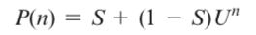
When S increases, (1–S) decreases, so U^n is multiplied by a smaller number

Sources: Textbook

Q-3. If the probability of a “super-event” decreases, what happens to the likelihood of needing multiple suppliers?

As the likelihood of a super event decreases, the likelihood of needing multiple suppliers increases. The decrease in the probability of a super event reduces the risk of disruption as the suppliers are in a position to make supply with low disruption. It indicates that the capability of each supplier to supply goods or to offer supplies enhanced. An increase in the competency of the supplier is a potential reason for the supplier to demand
conditions.
Advantages of supplier diversification are highest because as each supplier is added to the mix, the probability of all failing at the same time decreases significantly.

When S decreases, (1–S) increases, so U^n is multiplied by a larger number.

Sources: Textbook

Q-4. Describe some ramifications of the bullwhip effect.

The bullwhip effect causes individuals from the supply chain to overreact to changes sought after at the retail level. Small changes in demand at the buyer level may bring about enormous ones at the supplier level.

- Stockouts: a stockout is when you overcompensate or if customer demand jumps. If consumer demand is lower than you expect, resulting in excess inventory, the bullwhip effect dictates that the psychological response is to lower supply on future inventory orders.
- Tense supplier relationships: Unexpectedly high demand, for instance, could mean asking suppliers to quickly produce or ship high levels of inventory right away.
- Changes in buying patterns: When companies experience the bullwhip effect consistently and in extremes, they may consider changing buying or ordering processes. Batch ordering, where you buy large amounts of product infrequently, contributes to the bullwhip effect.

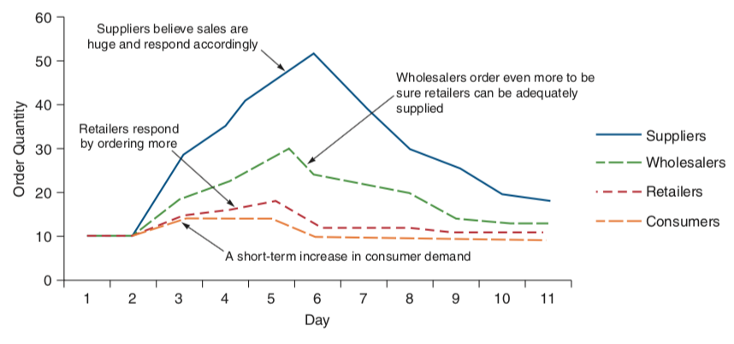

Sources: Textbook
https://www.tradegecko.com/inventory-management/bullwhip-effect

Q-5. Describe causes of the bullwhip effect and their associated remedies

- Demand forecast error: Give insight of demand information to the entire supply chain.
- Order size to be made: Consider one company as the full supply chain in order to determine lot sizes.
- Price fluctuations: Stabilized prices every day.
- Shortage gaming: Consider past demand trends in order to issue orders.

Sources: Textbook

Q-6. Describe how the bullwhip measure can be used to analyze supply chains.

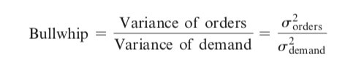
- More than 1 = fluctuations in orders is more than demand
- Equals 1= no amplifications
- Less than 1= Flattened graph, orders move up the supply chain towards suppliers. Positive correlations.
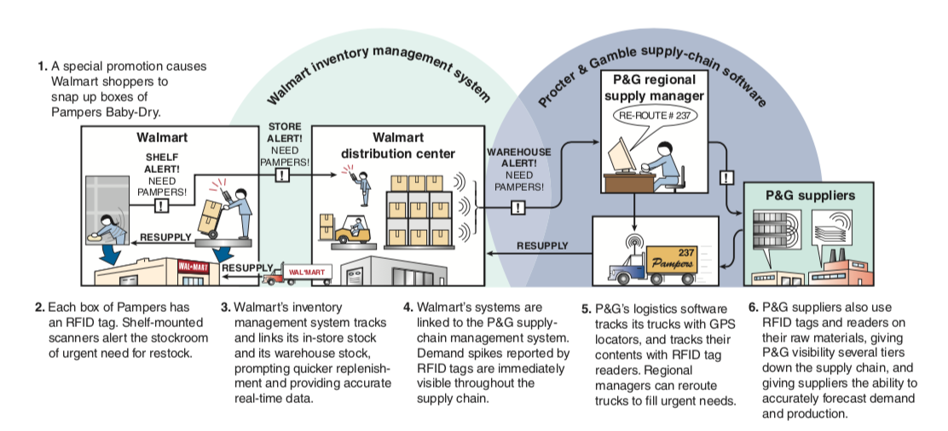

Sources: Textbook
https://www.researchgate.net/publication/235261785_Measuring_the_Bullwhip_Effect_in_the_Supply_Chain

Q-7. Describe some potentially useful categories to include in a factor-weighting analysis for supplier selection.

The factor-weighting system considers multiple supplier criteria. Each factor must be relegated an importance weight, and afterward, every potential supplier is scored on each factor. The weights are normally a sum of 100%. Factors are scored utilizing a similar scale (1–10). Here and there a key is provided for supplier raters that change qualitative ratings into numerical scores (e.g., “Very good” 5-8).

- Product quality
- Delivery speed
- Customer service
- Financial performance
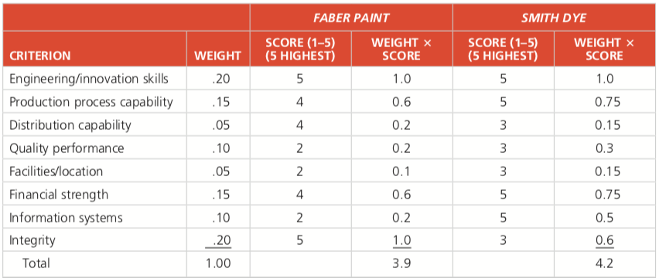

Sources: Textbook
https://www.researchgate.net/publication/264837173_Analysis_of_supplier_selection_methods_through_analytical_approach

Q-8. Describe some potential pitfalls in relying solely on the results of a factor-weighting analysis for supplier selection.

- Assumptions and perceptions of the analysis tend to change, they get influenced by competitors.
- Whenever the selection process occurs, there is a possible threat the existing suppliers could reduce their reliability which may adversely impact the organization.
- During the time spent classifying or gathering the criteria, the trouble may emerge when it requires including only one factor in a criterion.
- Weightings of the criteria may be corresponding to their loadings which might not exclude different elements for decision making
- The difficulty may emerge in cross-loading, the basis may be loaded with more than one factor which may make it hard to make critical decisions.

Sources: Textbook
https://www.semanticscholar.org/paper/Factor-Analysis-and-Methods-of-Supplier-Selection-Mak-Nebebe/c32c469833f9253a7cdf14a5b1ad1550ce08c9cf

Q-9. Describe some disadvantages of using a slow shipping method.

- Some customers would rather not wait for shipping and would pay more just to get products faster.
- Keeping goods secure for long periods of time cost more.
- Unable to meet up with fluctuation in market requirement (high demand, low demand, economic downfall etc.)

Sources: Textbook
https://www.process.st/shipping-processes/

Q-10. Besides warehouse layout decisions, what are some other applications where ranking items according to “bang/buck” might make sense?

- Labor: Arranging and tracking the workforce through spreadsheets is a manual procedure that doesn't create an exact perspective on assignments in the warehouse or permit the executives to recognize inefficiencies. Incorporation of labor-management can decrease costs up to 30% by recognizing zones of performance as well as inefficiencies.
- Operations: Distinguish your best employers, use critical thinking, Improve processes day by day, Get rid of excess stock, Replace checking with auditing, Damage reduction.
- Technology: Consider a new, advanced Warehouse Management, Use Electronic Data Interface

Sources: Textbook
https://www.interlakemecalux.com/warehouse-manual/warehouse-design/warehouse-layout

-

